Case Report

National Gallery DC

### Tracy’s iPhone [2012-07-15-National-Gallery]

# Table of Contents

Case Report

National Gallery DC

Tracy’s iPhone [2012-07-15-National-Gallery]

Table of Contents

Executive Summary

Equipment and Tools

Details of Tracy’s iPhone

Evidence to Establish Personas

Evidence relating to theft of valuable stamps

Evidence relating to defacement of museum art

Plot Timeline

Conclusion

Appendix A: Correspondence Evidence

Appendix B: WiFi and GPS Location Information

# Executive Summary

On January 21, 2016, Digitech Inc. was called in to assist the National Gallery, Washington D.C. (NGDC) case involving the conspiracy associated with the theft of valuable stamps and defacing of museums are at the NGDC.

* Tracy is a suspect in the aforementioned conspiracy.
* As part of the investigation, Tracy’s iPhone was taken into custody.
* Digitech, Inc. was tasked with investigating evidence relevant to the aforementioned conspiracy.

As described fully in the report, Digitech, Inc. made the following findings.

[Provide a brief summary of your findings here.]

Tracy works at the museum and found out there was a flash mob going on. She was assisting in getting them access to the National Art Gallery and was going to use this as a distraction to have her and her colleagues break into the stamp exhibit and steal approximately $260,000 dollars worth of stamps. Tracy shared security shift information for the National Art Gallery as well as bringing in a tablet to said venue after being compensated from Carry, who is connected to the defacing accusation. Tracy’s ex husband had installed a monitoring tool on her phone while they were still together and learned of this robbery and had alerted the authorities.

There was incriminating evidence found on the confiscated phone. Which includes planning the heist along with describing tools and methods of stealing the valuable stamps.

### Equipment and Tools

<Briefly summarize the equipment and tools you used to gather and analyze the evidence.>

The phone image was uploaded to “Autopsy” a file inspection and extraction tool used to view data and files on devices along with extraction of the data without changes to the integrity of the original device.

Linux terminal was used with the text editor “nano” to assist in viewing the information in a more readable format that is not available within the “Autopsy” tool.

The “archive manager” a tool built into the Linux operating system was used to navigate the zipped files that were pulled from the “autopsy” program that placed the files locally on the computer for further inspection after they were flagged.

# Details of Tracy’s iPhone

[Add Tracy’s iPhone Details worksheet from Day 2 here.]

| **Name** | **Findings** | **Location in iPhone image file** |
| --- | --- | --- |
| Model | IPhone 1,2 | /vol_vol5/logs/AppleSupport/general.log |
| Host Name | Tracy Sumtwelve | /vol_vol5/logs/lockdownd.log |
| OS Version | IPhone OS 4.2.1 | /vol_vol5/logs/AppleSupport/general.log |
| Install Time | 6/6/2012 12:03:28 -0700 | /vol_vol5/logs/AppleSupport/general.log |
| User Email | [tracysumtwelve@gmail.com](mailto:tracysumtwelve@gmail.com)  [tracysumtwelve@nationalgallergydc.org](mailto:tracysumtwelve@nationalgallergydc.org)  coralbluetwo@hotmail.com | /vol_vol5/mobile/Library/Mail |
| Phone Number | 703-340-9661 | /vol_vol5/logs/lockdownd.log |
| Serial Number | 86004482Y7H | /vol_vol5/logs/AppleSupport/general.log |
| ICCID | 89014103255195342366 | /vol_vol5/logs/lockdownd.log |
| IMEI | 004999010640000 | /vol_vol4/usr/libexec/lockdownd |

# Evidence to Establish Personas

This section establishes aliases, phone numbers, emails addresses associated with each person, and relationships between each individual.

Tracy:

Phone Number: (703) 340-9961

Personal Email: [tracysumtwelve@gmail.com](mailto:tracysumtwelve@gmail.com)

coralbluetwo@hotmail.com

Work Email: tracy.sumtwelve@nationalgallerydc.org

Relationship: Accused

Pat:

Phone Number: (571) 308-3236

Email: patsumtwelve@[gmail.com](http://gmail.com/perrypatsum@yahoo.com)

[perrypatsum@yahoo.com](http://gmail.com/perrypatsum@yahoo.com)

Relationship: Brother

Terry:

Phone Number: (703) 829-6071

Email: Not recovered

Relationship: Daughter

Joe:

Phone Number: Not recovered

Email: joe.sum.twelve@gmail.com

Relationship: Ex-Husband

Carry:

Phone Number: (202) 725-2124

Email: carrysum2012@yahoo.com

Relationship: Co-conspirator

King:

Email: [throne1966@hotmail.com](mailto:throne1966@hotmail.com)

Relationship: acquaintance of Pat

[Provide a summary of your conclusions here.]

# Evidence relating to theft of valuable stamps

This sub-section provides details regarding the evidence found as it relates to the theft of valuable stamps.

[Provide a summary of your conclusions here. Refer to specific artifact numbers from Appendix A and B (see below) to support your conclusions.]

Within the email sent from [patsumtwelve@gmail.com](mailto:patsumtwelve@gmail.com) there was talk of the heist itself. They described what needed to be done to commit the heist at the art gallery. There was also an attached file with a list of tools that they will use during the heist. This file is located at “/vol_vol5/mobile/Library/Mail/POP-coralbluetwo@hotmail.com@[pop3.live.com/inbox.mbox/messages](http://pop3.live.com/inbox.mbox/messages)” This message was sent at 2012-07-12 14:51:14 EDT.

To gain an understanding of the value of the stamps, they had sent an email listing the current insurance value of each item that was being held at the gallery. The three .pdf files that contained that information were sent to [coralbluetwo@hotmail.com](mailto:coralbluetwo@hotmail.com). The files were located at “/vol_vol5/mobile/Library/Mail/POP-coralbluetwo@hotmail.com@[pop3.live.com/INBOX.mbox/Attachments/61/2](http://pop3.live.com/INBOX.mbox/Attachments/61/2)” this message was sent at 2012-07-12 14:51:36 EDT.

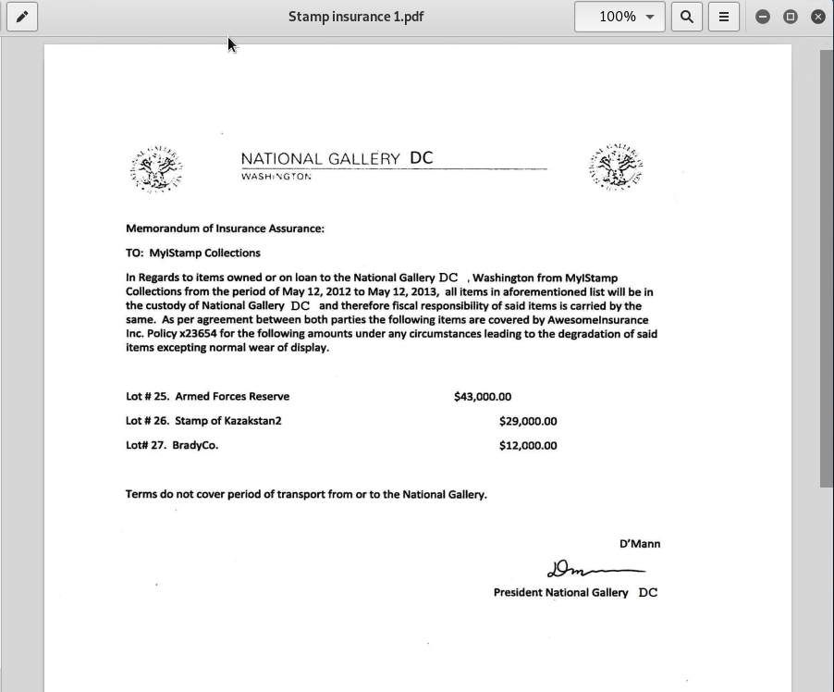

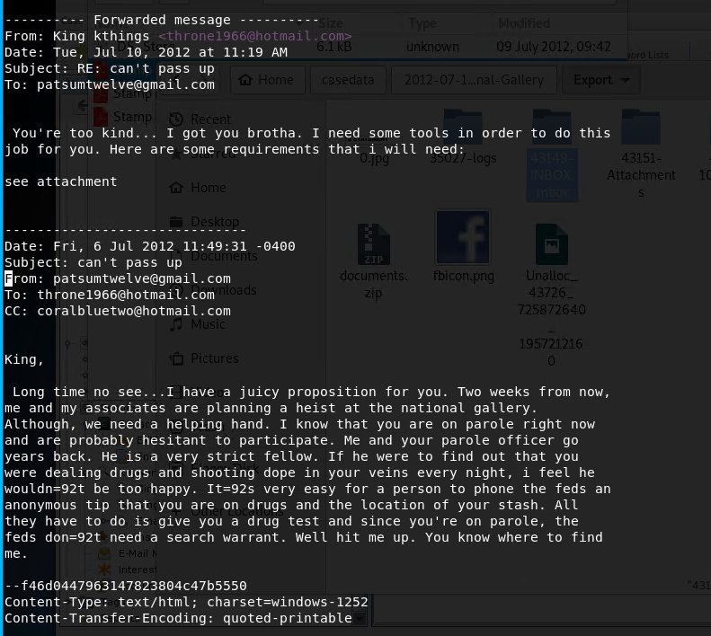

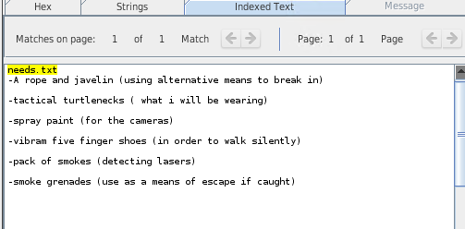

# Evidence relating to defacement of museum art

This sub-section provides details regarding the evidence found as it relates to the defacement of museum art.

[Provide a summary of your conclusions here. Refer to specific artifact numbers from Appendix A and B (see below) to support your conclusions.]

Carry made contact with Tracy via email (Article 14) followed by sms (Articles 32,33) about meeting at a bar 7/5/2012 with further sms (Articles 39,40) that confirms meeting on 7/6/2012. Articles 19,20 show emails dated 7/9-7/10/2012 of a proposition from Carry to Tracy of bringing in a tablet for a flash mob in which Tracy agrees. Carry also makes another proposition to Tracy, which she agrees to, for security detail info for the National Gallery, shown in email Articles 22/23. This was made after Tracy met to obtain Carry’s tablet shown in Articles 47/48 via SMS which she later shared info from tablet to Carry via email (Articles 24/25) that occurred on 7/11/2012

# Plot Timeline

[Provide an outline of the key events in the order they occurred. Note the date of each event.]

Jul 6 planning started

Jul 10 equipment gathered

Jul 20 heist to take place

# Conclusion

Evidence found on Tracy’s iPhone indicated the following:

* [Summarize your final conclusions of the case and Tracy’s Iphone here.]
* [For example: Tracy used the alias Coral and Pat used the alias Perry.]

Tracy played a major role within the attempted theft of valuable stamps from the art museum. Tracy had provided information such as the value of the stamps to

# Appendix A: Correspondence Evidence

This subsection will provide an amalgamation of the email and SMS corresponce evidence.

[Paste your Correspondence Evidence Worksheet here.]

# Correspondence Evidence Worksheet

### Group members:

### 

| Master Timeline of NGDC | | | | |
| --- | --- | --- | --- | --- |
| Artifact # | Timestamp | Header Information | Key Information | Evidence Location |
| 1. | 6/19/2012 20:06:33 | F: patsumtwelve@gmail.com  T: tracysumtwelve@gmail.com  Subject: Paris Speak and answer | Pat emails Tracy letting her know that he has accepted her proposal and asks her to email using her alias for further instructions. | Mailbox Data Structure |
| 2. | 6/19/2012 20:26:47 | F: perrypatsum@yahoo.com  T: tracysumtwelve@gmail.com  Subject: Look me up sometime | Pat (Perry) emails Tracy to ask her to communicate using her alias. | Mailbox Data Structure |
| 3. | 6/19/2012 21:38:59 | F: perrypatsum@yahoo.com  T: coralbluetwo@hotmail.com  Subject: Crazydave by the VMs Attachment: Crazydave1.mp3 | Pat (Perry) emails Tracy (Coral) with instructions to install a Virtual Machine hidden in an audio file. | Mailbox Data Structure |
| 4. | 6/19/2012 21:39:34 | F: perrypatsum@yahoo.com  T: coralbluetwo@hotmail.com  Subject: Re: ??? | Pat (Perry) replies to Tracy (Coral) confirming that he was getting her emails. | Mailbox Data Structure |
| 5. | 6/21/2012 17:43:15 | F: perrypatsum@yahoo.com  T: coralbluetwo@hotmail.com  Subject: Re: Crazydave by the VMs | Pat (Perry) replies to Tracy (Coral) on a email thread about Virtual Machine installation saying that she should listen to some other songs as well.  In the email thread Tracy (Coral) confirms that the instructions sent earlier in the audio file helped her. | Mailbox Data Structure |
| 6. | 6/28/2012 19:31:33 | 6/28/2012 19:31:33  F: perrypatsum@yahoo.com  T: coralbluetwo@hotmail.com  Subject: Whats going on | Pat (Perry) emails Tracy (Coral) asking her to henceforth communicate using the aliases and the Virtual Machine setup to keep them safer. He also indicates that they might have to get into riskier/illegal business since both of them were facing financial hardships.  He tells her that few of his workplace friends were good at these businesses and that he will inform her should something pop-up; in the meantime they should keep discussing some ideas for the same. | Mailbox Data Structure |
| 7. | 6/29/2012 14:21:56 | F: perrypatsum@yahoo.com  T: coralbluetwo@hotmail.com  Subject: Re: Whats going on | This is an email thread between Pat (Perry) and Tracy (Coral) discussing ideas for making some money.  To Pat’s suggestion that they use the Virtual Machines and aliases to communicate and keep looking for ways to make money, Tracy replies that she will keep her eyes open for opportunities and insists that Pat try to get in on some business soon, since her kid didn’t want to change schools. She also indicates that she is paying attention to documents especially insurance papers so that she could identify something of potential. Pat assures that he will make something happen although he is nervous because IA has been sniffing around. | Mailbox Data Structure |
| 8. | 6/29/2012 14:31:36 | F: perrypatsum@yahoo.com  T: tracysumtwelve@gmail.com  Subject: hey sis | Pat (Perry) emails Tracy addressing her as ‘sister’ and enquires about Terry. Asks her to check in with Coral with whom he has been planning some things. He also suggests all of them going together for dinner as friends.  He asks Tracy to check in with Coral.  Possible misdirection attempted by referring to Coral as a third person in the narrative. | Mailbox Data Structure |
| 9. | 6/29/2012 15:21:35 | F: perrypatsum@yahoo.com  T: coralbluetwo@hotmail.com  Subject: Re: Whats going on | Pat (Perry) replies to the email thread allaying Tracy’s (Coral) concern about IA sniffing around him. Tracy in her earlier email in the thread says that although nothing interesting has turned up yet she expects something soon. Pat in his email mentions that they can certainly get the job done if something like what they had earlier discussed pops up. | Mailbox Data Structure |
| 10. | 7/2/2012 16:13:18 | F: perrypatsum@yahoo.com  T: coralbluetwo@hotmail.com  Subject: Re: Some good news | Email Thread: Some good news  Tracy (Coral) emails Pat (Perry) mentioning that some interesting foreign exhibit is going to happen and that from assessing the paperwork she feels that it would be a big deal.  Pat (Perry) replies back feeling hopeful about this being the opportunity they were looking for. | Mailbox Data Structure |
| 11. | 7/2/2012 20:00:31 | F: perrypatsum@yahoo.com  T: coralbluetwo@hotmail.com  Subject: Re: Some good news | Email thread: Some good news  Following up on the earlier email about the exhibit, Tracy (Coral) mentions going through documents related to the exhibit from which she found that the exhibit is worth a lot of money but the shipping cost is very low comparatively.  Pat (Perry) emails back saying that such a thing may mean that the exhibit is something small which would be a very good thing for them. | Mailbox Data Structure |
| 12. | 7/3/2012 13:29:37 | F: joe.sum.twelve@gmail.com  T: tracysumtwelve@gmail.com  Subject: Re: Regarding Terry | Email Thread: Regarding Terry  Tracy emails Joe asking whether he could help her with Terry’s tuition this year since it is becoming too expensive for her.  Joe replies back saying that he won’t be paying Terry’s tuition if she is not living with him. | Mailbox Data Structure |
| 13. | 7/3/2012 14:53:04 | F: perrypatsum@yahoo.com  T :coralbluetwo@hotmail.com  Subject: Re: Some good news | Email Thread: Some good news  Tracy (Coral) emails Pat (Perry) saying that the exhibit is rare and highly valuable stamp collection and that may be this is their opportunity.  Pat (Perry) replies to Tracy (Coral) asking her to collect as much information as possible about the stamp exhibit and that in the meantime he would look into options for pulling off the heist. | Mailbox Data Structure |
| 14. | 7/5/2012 15:51:31 | F: carrysum2012@yahoo.com  T: tracysumtwelve@gmail.com  Subject: Long time no see... | Carry reaches out to Tracy asking her if they could meet-up for lunch and suggests this Friday. She also mentions that through Facebook she realized that Tracy was having a hard time recently. | Mailbox Data Structure |
| 15. | 7/6/2012 15:27:51 | F: patsumtwelve@gmail.com  T: tracysumtwelve@gmail.com  Subject: Re: Good News | Email Thread: Good News  Tracy emailed Pat saying that she spoke with Coral and that Coral got some great news about her job and suggested that Pat catch up with Coral.  Pat replied back saying that he knows a guy called King. | Mailbox Data Structure |
| 16. | 7/6/2012 15:49:31 | F: patsumtwelve@gmail.com  T: throne1966@hotmail.com  Cc:coralbluetwo@hotmail.com  Subject: can't pass up | Pat emails King with Tracy (Coral) in cc, saying that he has a lucrative proposition, a heist at national gallery. He also threatens King to comply or else he would put King’s parole in jeopardy. | Mailbox Data Structure |
| 17. | 7/6/2012 17:59:24 | F: patsumtwelve@gmail.com  T: tracysumtwelve@gmail.com  Subject: Re: Good News | Email Thread: Good News  Tracy suggests they (meaning King, Tracy and Pat) should hang out sometime.  Pat emails Tracy with account login information for:  coralblue@hotmail.com  Password: legalBee | Mailbox Data Structure |
| 18. | 7/9/2012 14:44:11 | F: tracysumtwelve@gmail.com  T: coralbluetwo@hotmail.com  Subject: things | documents.zip is a compressed ZIP folder containing 3 insurance documents related to stamps.  docs.zip is an encrypted ZIP folder containing 3 insurance documents related to stamps. | /mobile/Librar y/Mail/POP- coralbluetwo @hotmail.com @pop3.live.co m/INBOX.mbo x/Messages/8 A3BD06F- CDB1-4453- 9C69- 77E06823F2A E.emlx |
| 19. | 7/9/2012 18:18:47 | F: carrysum2012@yahoo.com  T: tracysumtwelve@gmail.com  Subject: Re: Long time no see.. | Email Thread: Long time no see... Tracy thanked Carry for the lunch.  Carry emails Tracy asking for help sneaking in a tablet for a flash mob event they had spoken earlier about. Carry suggests that Tracy would be compensated in some way for the help. | Mailbox Data Structure |
| 20. | 7/10/2012 13:48:40 | F: carrysum2012@yahoo.com  T: tracysumtwelve@gmail.com  Subject: Re: Long time no see... | Email Thread: Long time no see…  Tracy agrees to help Carry sneak in the tablet and asks when Carry would like to get in to take a look around the gallery.  Carry replies saying that this would be a big help and asks if she could come around 9 tomorrow. | Mailbox Data Structure |
| 21 | 7/10/2012 15:24:57 | F: patsumtwelve@gmail.com  T: coralbluetwo@hotmail.com  Subject: Fwd: can't pass up  Attachment: needs.txt | Email Thread: cant’ pass up  King agrees to help with the heist and sends in a document with equipment required for it. The attached document is saved as a ‘txt’ file.  Pat forwards that email to Tracy (Coral)  *needs.txt is a pdf file which was saved with a wrong extension. | /mobile/Librar y/Mail/POP- coralbluetwo @hotmail.com @pop3.live.co m/INBOX.mbo x/Messages/9 F0508B8- 04FB-490E- A7F0- 3E23B0E7C5 9B.emlx |
| 22. | 7/11/2012 17:06:19 | F: carrysum2012@yahoo.com  T: tracysumtwelve@gmail.com  Subject: Re: Long time no see... | Email Thread: Long time no see  Tracy confirms the meet at 9 tomorrow.  Carry wants Tracy to pass her information regarding shift changes of security. She suggests that Tracy would be well compensated for the information.  Tracy confirms that she will give the security shift information Carry requested in exchange for money but asks Carry to be careful with it.  Carry replies asking Tracy not to worry and says “It will be gun”. | Mailbox Data Structure |
| 23. | 7/11/2012 19:28:53 | F: "Google+" <noreply- 5dd47ca1@plus.google.com>  T: tracysumtwelve@gmail.com  Subject: Carry Carsumtwotwelve added you on Google+ | Email Thread: Long time no see  Previous email from the thread from Carry asking for the security shift details from Tracy. | Mailbox Data Structure |
| 24. | 7/11/2012 23:22:03 | F: "Carry Carsumtwotwelve (Google+)" <replyto- 748d3d22@plus.google.com>  T: tracysumtwelve@gmail.com    Subject: Carry Carsumtwotwelve is sharing with you on Google+ | Notification from Google+ informing Tracy that Carry had shared an album. | Mailbox Data Structure |
| 25. | 7/12/2012 16:12:07 | F: "Carry Carsumtwotwelve (Google+)" <replyto- 748d3d22@plus.google.com>  T: tracysumtwelve@gmail.com  Subject: Carry Carsumtwotwelve is sharing with you on Google+ | Notification from Google+ informing Tracy that Carry had shared an album. | Mailbox Data Structure |
| 26. | 7/12/2012 18:03:51 | F: carrysum2012@yahoo.com  T: tracysumtwelve@gmail.com  Subject: Re: Long time no see... | Email Thread: Long time no see...  Tracy emailed Carry asking her what she meant by “It will be gun”.  Carry replies saying that it was a typographical error and she meant “It will be fun”. | Mailbox Data Structure |
| 27. | 6/12/2012 21:25:04 | F: Pat  T: Tracy | Pat asks Tracy about her plans for the weekend | SMS |
| 28. | 6/13/2012 17:30:28 | F: Terry  T: Tracy | I'm going out with dad after school for pizza! Thought I'd let you know if you planned to cook. T | SMS |
| 29. | 6/13/2012 18:30:38 | F: Tracy  T: Pat | Tracy replies to Pats message saying that she has no big plans and enquires about his plans. | SMS |
| 30. | 6/13/2012 18:33:46 | F: Tracy  T: Terry | Ok, sounds good. | SMS |
| 31. | 7/3/2012 14:04:32 | F: Terry T: Tracy | Terry replies back saying that she doesn’t want to switch schools and would rather stay with her dad and continue at Prufrock | SMS |
| 32. | 7/5/2012 18:18:23 | F: Carry T: Tracy | Carry sets up the time and location as 1pm at Bubba’s grill for meeting with Tracy | SMS |
| 33. | 7/5/2012 18:20:26 | F: Tracy T: Carry | Tracy confirms the meeting time and location | SMS |
| 34. | 7/6/2012 15:02:19 | F: Tracy T: Pat | Tracy asks Pat to give her a call | SMS |
| 35. | 7/6/2012 15:08:37 | F: Pat T: Tracy | Pat says he is busy and suggests calling later | SMS |
| 36. | 7/6/2012 15:11:54 | F: Tracy T: Pat | Tracy says its important and insists that pat call her soon | SMS |
| 37. | 7/6/2012 15:13:31 | F: Pat T: Tracy | Pat says he will call in 5 min | SMS |
| 38. | 7/6/2012 15:18:50 | F: Pat T: Tracy | Pat calls Tracy and they speak for 4 min 4 secs. | SMS |
| 39. | 7/6/2012 16:27:16 | F: Carry  T: Tracy | Carry messages saying she has a table inside | SMS |
| 40. | 7/6/2012 16:27:50 | F: Tracy  T: Carry | Tracy replies back saying that she will be there. | SMS |
| 41. | 7/10/2012 15:26:19 | F: Pat  T: Tracy | Pat messages Tracy telling her about the email and informing that the attachment needs to be changed to pdf. He asks Tracy to tell this information to Coral. | SMS |
| 42. | 7/10/2012 15:58:04 | F: Tracy  T: Pat | Tracy acknowledges the email and message. | SMS |
| 43. | 7/10/2012 16:37:09 | F: Tracy T: Pat *Failed | Tracy tried to share the following location with Pat over MMS message but it failed. Location: 2600-2700 24th Rd S, Arlington, VA 22206 | SMS |
| 44. | 7/10/2012 17:18:38 | F: Tracy T: Terry | Tracy messages Terry for Lunch | SMS |
| 45. | 7/10/2012 18:19:24 | F: Tracy T: Terry | Tracy messages Terry that she is back at work. | SMS |
| 46. | 7/10/2012 18:58:24 | F: Terry T: Tracy | Terry messages Tracy saying she is busy and suggests meeting up over the weekend if her dad isn’t busy. | SMS |
| 47. | 7/11/2012 12:41:45 | F: Carry T: Tracy | Carry messages Tracy informing that she is almost there (National Gallery) | SMS |
| 48. | 7/11/2012 12:49:08 | F: Tracy T: Carry | Tracy replies to Carry asking her to meet out front. She says that she will take the tablet in. | SMS |
| 49. | 7/13/2012 1:02:10 | F: Terry T: Tracy | I really want to go to Dad's this weekend. He said he'll take me shopping for school | SMS |
|  |  |  |  |  |
|  |  |  |  |  |
|  |  |  |  |  |
|  |  |  |  |  |
|  |  |  |  |  |
|  |  |  |  |  |
|  |  |  |  |  |
|  |  |  |  |  |
|  |  |  |  |  |
|  |  |  |  |  |
|  |  |  |  |  |
|  |  |  |  |  |
|  |  |  |  |  |
|  |  |  |  |  |
|  |  |  |  |  |
|  |  |  |  |  |
|  |  |  |  |  |
|  |  |  |  |  |
|  |  |  |  |  |
|  |  |  |  |  |
|  |  |  |  |  |
|  |  |  |  |  |

### 

# Appendix B: WiFi and GPS Location Information

# Location Information Worksheet

### Group members: Austin Stevens, Evan Hobson, Steve Hendren

### 

| Location Information | | | | |
| --- | --- | --- | --- | --- |
| Artifact # | Timestamp | Header Information | Body | Map Screenshot |
| 1 | 13 Jun 2021 19:01:22 UTC | 38.88014435,-77.11625033 | Vicinity of 801 Wakefield St, Arlington, VA 22203 |  |
| 2 | 03 Jul 2012 13:42:42 UTC | 38.88143724,-77.11478394 | Vicinity of 851 Glebe Rd, Arlington, VA 22203 |  |
| 3 | 05 Jul 2012-07 16:32:47 UTC | 38.88054466, -77.11439651 | Vicinity of 901 Gelbe Rd, Arlington, VA 22203 |  |
| 4 | 10 Jul 2012 16:31:12 UTC | 38.84833276,-77.08220279 | General of 2693 24th Rd, Arlington, VA 22206  (This is area discovered in suspect’s map search history labeled “Cvs”) |  |
| 5 | 10 July 2012 16:45:01 UTC | 38.82764369, -77.08806616 | General vicinity of 4104 36th St S, Arlington, VA 22206 |  |

### 